If this message is not displaying properly, click here to launch your browser.
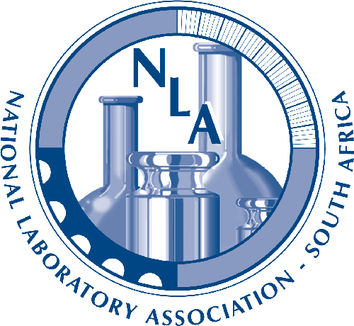  February 2012 | National Laboratory Association - South Africa  Do not use the sender's email to respond!!. Please use the email addresses below.
NLA - SA  1 De Havilland Crescent  Persequor TechnoPark  Pretoria  South Africa  Tel: +2712 349 1500  Fax: +2712 349 1501  www.nla.org.za | Call for Papers  Test & Measurement 2012 Conference  2 - 5 September 2012  ABSTRACT DUE EXTENDED  The Technical Chair for the Test & Measurement 2012 Conference would like to inform the laboratory community that the deadline for submission of asbtracts for this event has been extended to the 15th March 2012.  Thanks are due to all who have made a submission so far, but would like to advise everyone that there are still many opportunities for you to make a contribution. We would like to encourage everyone to take the opportunity of this extension to submit their abstract/s. (Please note that you can make more than one submission and if you have any difficulties with this, please contact the NLA office.)  As in the past representatives from all over South Africa as well as Southern Africa and the rest of Africa are expected to attend; and together with various international attendees it gives this event a truly cosmopolitan flavour.  This year's theme for the T&M Conference, " The impact of reliable measurements on our environment ", is particularly relevent and the Technical Committee looks forward to receiving your abstract.  Please note that since there are also other very important aspects and issues that are relevant for the laboratory environment, eg. Accreditation, Traceability, Method Validation, Uncertainty of Measurement, Proficiency Testing to mention just a few, all abstracts submitted will be given due consideration.  Due date for submission of abstracts is: March 15th 2012.  To find out more, as well as make a submission, click on the link below.  NLA 2012 T&M Conference  The Technical Committe Chair is waiting to receive your contribution !!!!  National Laboratory Association-South Africa  Tel: +2712 349 1500 Fax: +2712 349 1501  Please contact either Maggie Rossouw maggier@nla.org.za or Hanlie Badenhorst hanlieb@nla.org.za if you have any additional questions.  Further details regarding all the services that the NLA provides can be found on our web site National Laboratory Association - South Africa.

